**DataBase Task – 3**

**-----------------------------------Create Table----------------------------------**

**Create table Student(student_id varchar(20), student_name varchar(30),marks number,grade varchar(2));**

**--------------------------------------Insert Data--------------------------------------**

**INSERT INTO Student (student_id, student_name, marks, grade)**

**VALUES ('GA-001', 'John', 285, 'A');**

**INSERT INTO Student (student_id, student_name, marks, grade)**

**VALUES ('GA-002', 'Smith', 248, 'B');**

**INSERT INTO Student (student_id, student_name, marks, grade)**

**VALUES ('GA-003', 'Emma', 329, 'A+');**

**INSERT INTO Student (student_id, student_name, marks, grade)**

**VALUES ('GA-004', 'Sandy', 249, 'B');**

**INSERT INTO Student (student_id, student_name, marks, grade)**

**VALUES ('GA-005', 'Olivea', 150, 'F');**

**INSERT INTO Student (student_id, student_name, marks, grade)**

**VALUES ('GA-006', 'James', 187, 'D');**

**INSERT INTO Student (student_id, student_name, marks, grade)**

**VALUES ('GA-007', 'Eva', 352, 'A+');**

**INSERT INTO Student (student_id, student_name, marks, grade)**

**VALUES ('GA-008', 'Noah', 279, 'B');**

**INSERT INTO Student (student_id, student_name, marks, grade)**

**VALUES ('GA-009', 'Charlotte', 282, 'A');**

**INSERT INTO Student (student_id, student_name, marks, grade)**

**VALUES ('GA-010', 'Elijhah', 301, 'A');**

**----------------------------------------Persentage----------------------------------------**

**UPDATE Student**

**SET PERSENTAGE = (marks / 400.0) * 100**

**WHERE student_id = 'GA-001';**

**UPDATE Student**

**SET PERSENTAGE = (marks / 400.0) * 100**

**WHERE student_id = 'GA-002';**

**UPDATE Student**

**SET PERSENTAGE = (marks / 400.0) * 100**

**WHERE student_id = 'GA-003';**

**UPDATE Student**

**SET PERSENTAGE = (marks / 400.0) * 100**

**WHERE student_id = 'GA-004';**

**UPDATE Student**

**SET PERSENTAGE = (marks / 400.0) * 100**

**WHERE student_id = 'GA-005';**

**UPDATE Student**

**SET PERSENTAGE = (marks / 400.0) * 100**

**WHERE student_id = 'GA-006';**

**UPDATE Student**

**SET PERSENTAGE = (marks / 400.0) * 100**

**WHERE student_id = 'GA-007';**

**UPDATE Student**

**SET PERSENTAGE = (marks / 400.0) * 100**

**WHERE student_id = 'GA-008';**

**UPDATE Student**

**SET PERSENTAGE = (marks / 400.0) * 100**

**WHERE student_id = 'GA-009';**

**UPDATE Student**

**SET PERSENTAGE = (marks / 400.0) * 100**

**WHERE student_id = 'GA-010';**

**--------------Query for added the Result to the table--------------**

**update student**

**set result = case**

**when grade = 'A' or grade = 'B' or grade = 'C' or grade = 'D' or grade = 'A+' then 'Pass'**

**else 'Fail'**

**end;**

**Fig : Table**

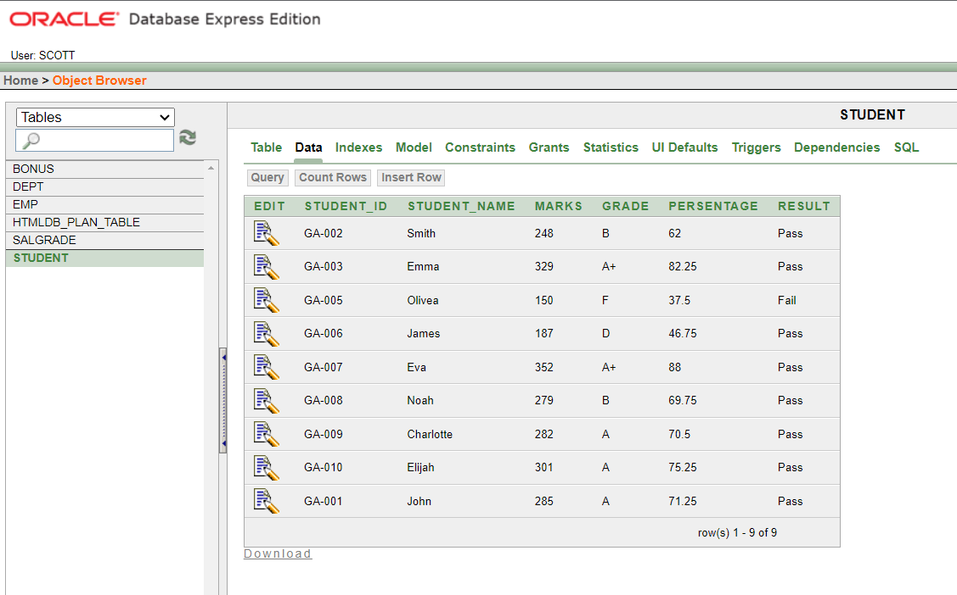

**Fig : Table Data**

**---------------------Query for Calculate the Result-----------------------**

**select student_id, student_name, marks,**

**case**

**when grade = 'A' or grade = 'B' or grade = 'C' or grade = 'D' or grade = 'A+' then 'Pass'**

**else 'Fail'**

**end as Result**

**from student;**

